**BANKING PROJECT**

Project Name : Loyalty And Transaction Module

Author : Developer Guide

Date Of Assignment: 10-09-2021

Date Of Submission: 10-09-2021

Document detail

|  |  |  |  |  |
| --- | --- | --- | --- | --- |
| Name | Description | Version | Comment | Date |
| Kumar | Initial Draft | 1.0 |  | 10-09-2021 |

Document Future Scope

|  |
| --- |
|  |
|  |
|  |
|  |
|  |

**Course Content**

* Requirement Gathering
* Project life-cycle discussion
* Agile Methodology discussion
* Jira Setup and management
* Confluence setup
* Bitbucket Setup and Management
* Bitbucket Pipeline
* Create RAML and best practice
* Develop API and best practice
* Local Testing
* Munit Testing
* Performance testing
* Code Check-in
* Discussion about deployment modal
* DEV and PROD Environment Setup
* Deploy application on Cloud-hub
* Environment promotion (DEV->PROD)
* Apply policy and security
* How to explain project in interview

|  |  |  |
| --- | --- | --- |
| **Connector** | **component** | **Policy** |
| Salesforce | Scatter-Gather | Client enforcement |
| DB | Batch Processing | Rate limiting |
| JMS | Parallel for each | Spike control |
| HTTP | Caching | HTTP Caching |
| Object store | Choice router | Basic Auth |
| Custom connector for logger | Error handling | JWT |
|  |  |  |

**Objective of this exercise**

* To simulate a real-world scenario, where a solution architecture document will be handed down to the development team to build & implement.
* Make use of MuleSoft out of the box capabilities (as much as possible) to come out with a solution to address the design problems addressed in the use case.
* Include previous best practices experience when coming out with the solution.
* Make use of Design Center to create RAML projects and design RAML specification base RAML best practices based on the business scenario given.
* Organize and create the mule projects based on the business scenarios, and solutions described in this document.
* Creating mule message flows, making use of mule components and connectors. implement a solution based on the scenario and specifications given in this document.
* M-unit test is created to test each of the possible scenarios.
* Test scripts creation to test the end point using testing tools such as Postman / Soap UI (if needed).
* Demo the working example at the end. During the presentation, outline in detail what you are trying to solve in your Mule project and the approach to resolve it.
* Extend and enhance your application in real-time.

Business Scenario

Transaction and Loyalty Module will contain APIs related to transaction process, point added in customer account after transaction , claim reward , redeem reward and revoke reward.

Flow Diagram

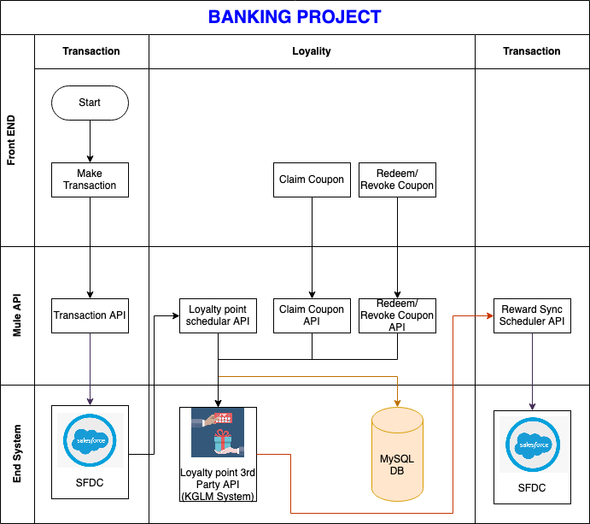

# 

# API Landscape

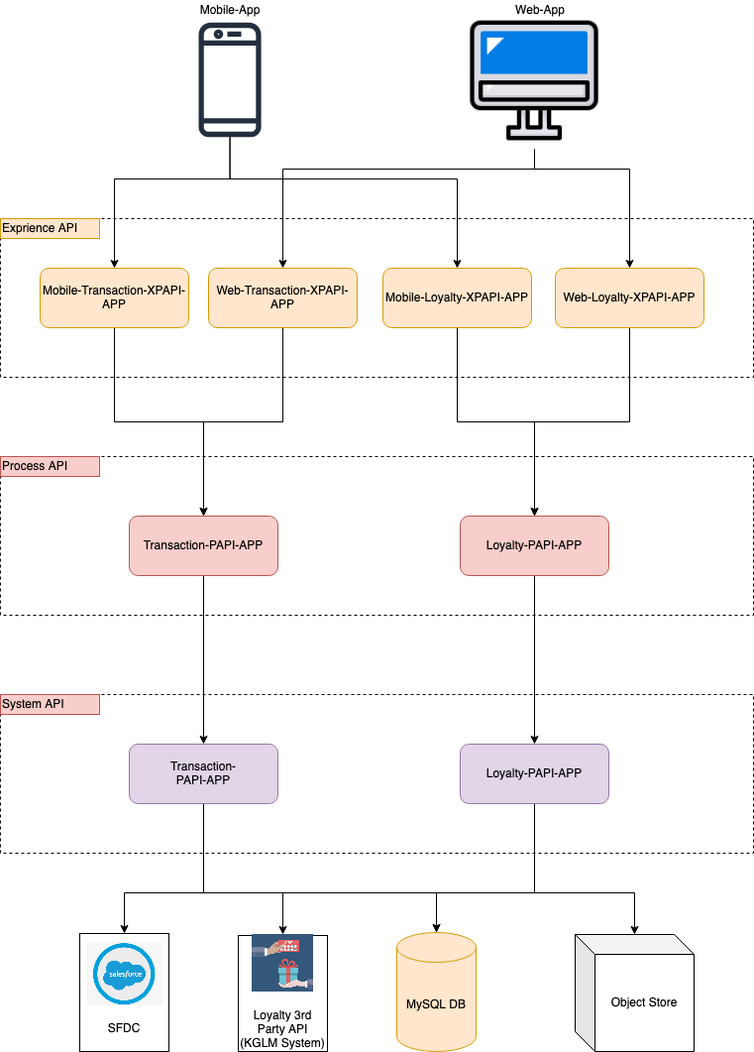

# Mobile-Transaction-XPAPI-APP

1. Post /transaction (post-transaction- implementation-xpapi)

# Mobile-Transaction-XPAPI-APP

1. Post /transaction (post-transaction- implementation-xpapi)

# Mobile-Transaction-XPAPI-APP

1. Post /transaction (post-transaction- implementation-xpapi)

# Mobile-Transaction-XPAPI-APP

1. Post /transaction (post-transaction-implementation-xpapi)

# Transaction-PAPI-APP

1. Post /transaction (post-transaction-implementation-papi)

# Loyalty-PAPI-APP

1. Post /coupon/claim (post-claim-coupon-implementation-papi)
2. Post /coupon/revoke (post-revoke-coupon-implementation-papi)
3. Post /redeem (post-redeem-reward-implementation-papi)
4. Post /revoke (post-revoke-reward-implementation-papi)

# Transaction-PAPI-APP

1. Post /transaction (post-transaction-implementation-sapi)

# Loyalty-PAPI-APP

1. Post /coupon/claim (post-claim-coupon-implementation-sapi)
2. Post /coupon/revoke (post-revoke-coupon-implementation-sapi)
3. Post /redeem (post-redeem-reward-implementation-sapi)
4. Post /revoke (post-revoke-reward-implementation-sapi)

**External System:**

1. **Salesforce**

Salesforce is a cloud computing service as a software (SaaS) company that specialises in customer relationship management (CRM). Salesforce's services allow businesses to use cloud technology to better connect with customers, partners and potential customers. The software has become the number one for customer success and helps businesses track customer activity, market to customers and many more services.

1. **Data Base**

A database is a collection of information that is organised so that it can be easily accessed, managed and updated. Computer databases typically contain aggregations of data records or files, containing information about sales transactions or interactions with specific customers.

1. **Object Store**

Often referred to as object-based storage, is a data storage architecture for handling large amounts of unstructured data. This is data that does not transform to or cannot be organised easily into a traditional relational database with rows and columns.

1. **External Loyalty API**

Loyalty API Assign any amount of wallets to each customer, then control how they save and spend with our ‘Earn & Burn’ feature directly in our customer loyalty software. Or use the wallet feature in gamification to store badges, points, XP or any counter you like.

.

1. **FrontEnd**

It is the website with which user interacts. It is also known as user interface.

Batch Details :

Start Date : 1st Oct 2021

Introduction session

SaturDay : 7:00 PM IST to 10:00 PM IST

SunDay : 7:00 PM IST to 10:00 PM IST

For Registration

Contact : WhatsApp : +91 7411764131